IDENTIFY CAR WASH SERVICES

Software Requirements Specification

|  |  |  |  |
| --- | --- | --- | --- |
|  | Prepared By | Reviewed By | Approved By |
| Name | Zahid Mohi Ud din | Venkataraman Chandrasekar |  |
| Role | Interns | Batch Trainer |  |

**Table of Contents**

Table of Contents…………………………………………………………..….......II

1. Introduction…………………………………………………………………..…1

1.1 Intended Audience……………………………………………….......1

1.2 Project Scope…………………………...……………………………1

2. Overall Description…………………………………………….……………….1

2.1 Operating Environment……………………...……………………....1

3. Requirements……………………………………………………………...…….1

3.1 Car Wash Search.…………………………………………………….2

3.1.1Description………………………………………………....2

3.1.2 Functional Requirements……..…………………………...2

**1. Introduction**

Door-Step Wash is an online website. We are taking and testing three functionalities of that website (i.e.)

1. Select service type as "car" and select subcategory as "SUV" and click "Go for it", capture all service name and amount.
2. Click on register and capture the error message by providing invalid input for email field.
3. Navigate to home page and click on "Our Centers". select state with city and click on search to capture the center name.

**1.1 Intended Audience**

* Business Unit (BU) SME
* Academy coach
* Technical Trainer

**1.2 Project Scope**

This document defines at a functional level the business activities that are encompassed by the system and the rules that apply to them. It also encompasses some of the key high- and low-level technical requirements of the system.

It draws heavily on both proposed Framework and Business Rules and the Technical Architecture documents. The scope of the detailed analysis project phase specifies that this document will include.

* Classification of requirements according to their functional areas.
* A description of each process in the system, including their inputs, outputs, and data transformation rules.

**2. Overall Description**

**2.1 Operating Environment**

* Windows operating system
* Web application

**3. Requirements**

This part of the requirements document serves to present the application and, we need to extract all the levels in Validation & Extract table values & store in excel, Filling data in screen.

**3.1.1 Functional Requirements**

**3.1.1.1 Req0001**

**Req0001a-**The user navigates to the URL.

**Req0001b**- The user selects the Service type as “Car”.

**Req0001c-**The user selects the Subcategory as “SUV”.

**Req0001d-** The user captures the service name with price.

**3.1.1.2 Req0002**

**Req0002a**- The user click on Register Button.

**Req0002b-** The user fills the relevant details with invalid email address.

**Req0002c-** The user captures the invalid Email address.

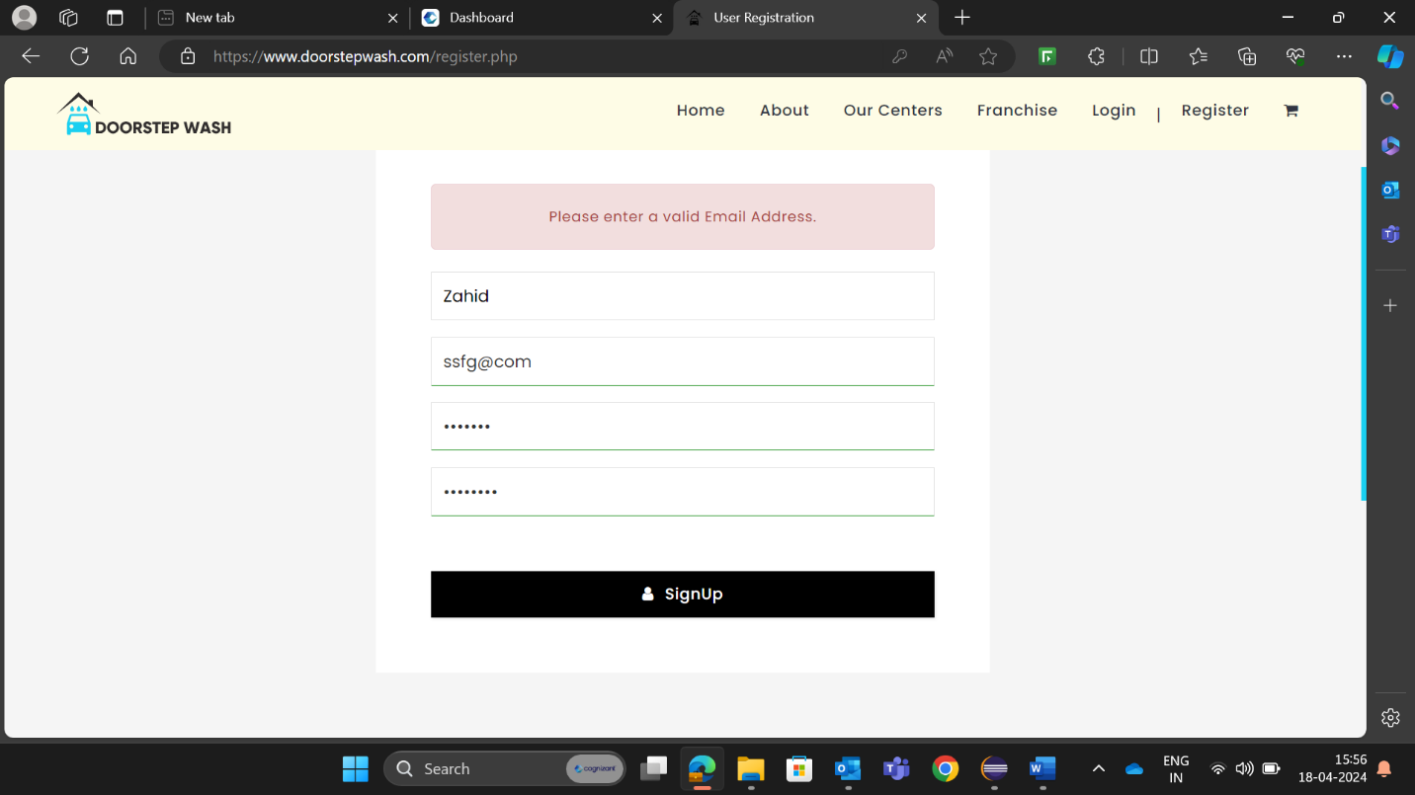

**3.1.2.3 Req0003**

**Req0003a**- The user navigates to Home Page.

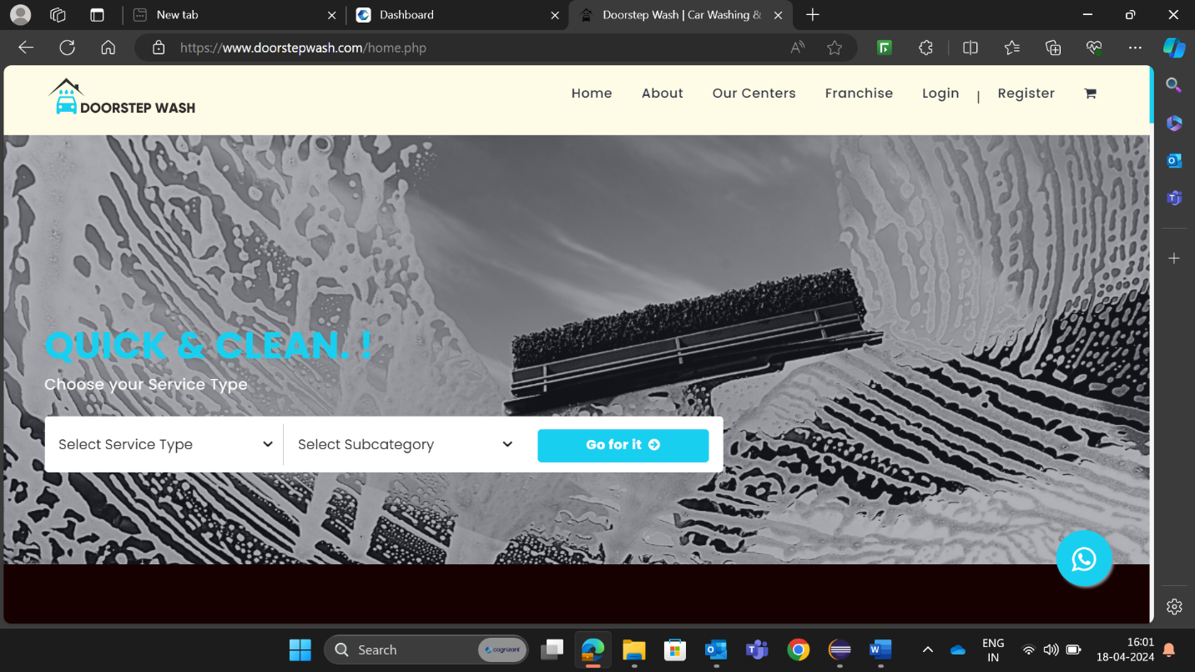

**Req0003b-** The user clicks on our centers button.

**Req0003c-** The user will select the state and city and capture the center name with three different states.

